# 

# Introduction to Modern Java

## Introduction

This lecture provides an introduction to modern Java, covering an overview of new features, the release cycle, and more. This is a theory-based lecture, and those familiar with modern Java and its release model may choose to skip it.

## What Does Java Primarily Mean?

When someone refers to Java, they are talking about either:

- Java as a programming language.

- Java as a platform (JDK), which includes JRE and the Java Virtual Machine (JVM) that executes bytecode.  
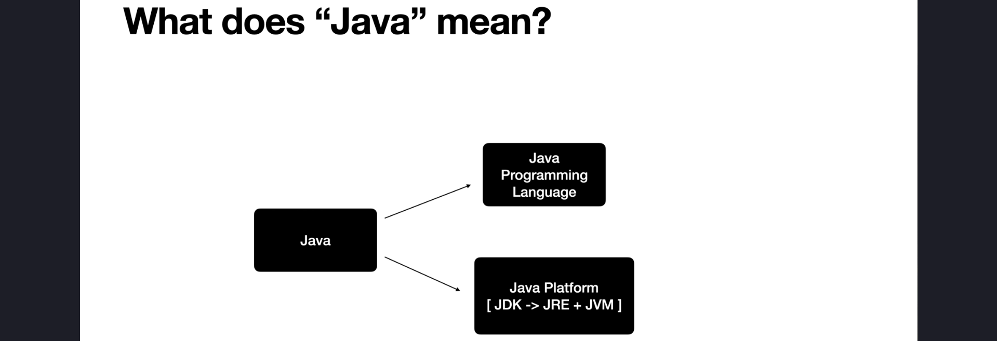

## Modern Java Features and Key Shifts



The term 'Modern Java' is used because Java continues to evolve with new features. Some key shifts include:

1. **Functional Programming (Java 8)** - Introduction of Lambdas, Streams, and functional programming features.

2. **Java Platform Module System (Java 9)** - Runtime libraries were modularized, replacing the monolithic `rt.jar`.

3. **Six-Month Release Cycle (Java 10 onwards)** - New Java features are released every six months.

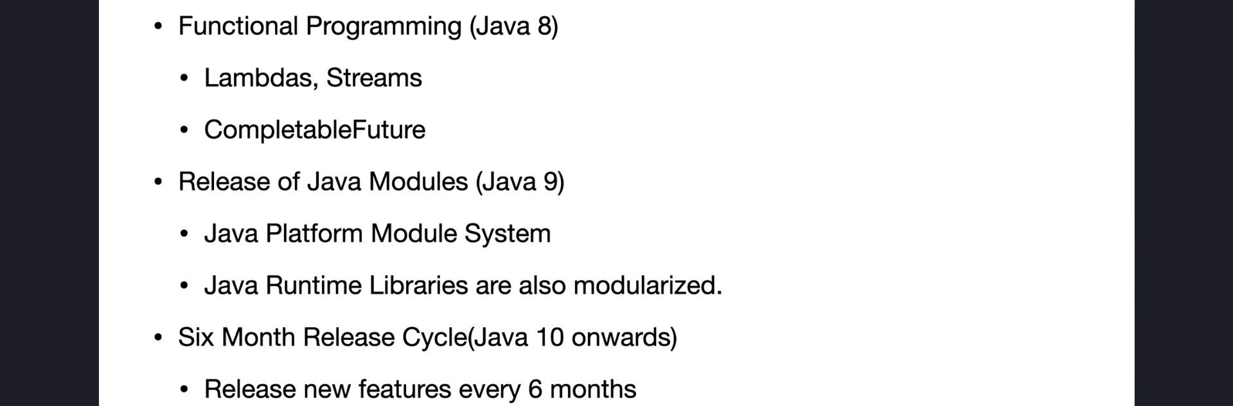

## Features Covered in This Course

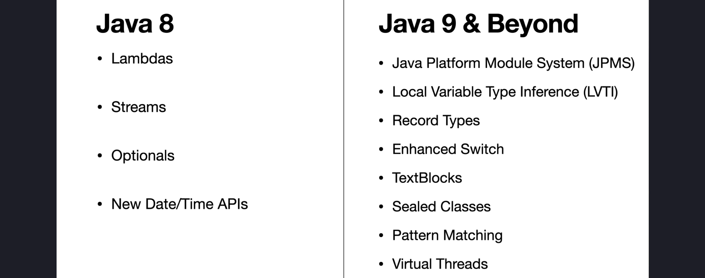 - Virtual Threads (excluded in this course, but covered in a separate course)  
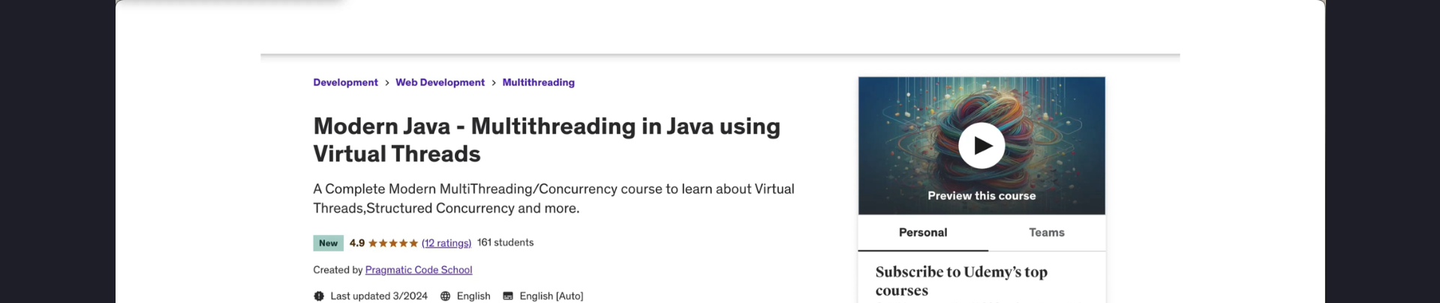

## Java Release Model

Java is an open-source language maintained under the OpenJDK project, supported by Oracle, Red Hat, and the community.

Java 7 was the first version released under an open-source license. Various organizations provide OpenJDK distributions, including:

- Oracle

- Eclipse Adoptium (Tamarin)

- Amazon (Corretto)

- Azul (Zing, Zulu)

- IBM, Microsoft, RedHat, SAP, and others

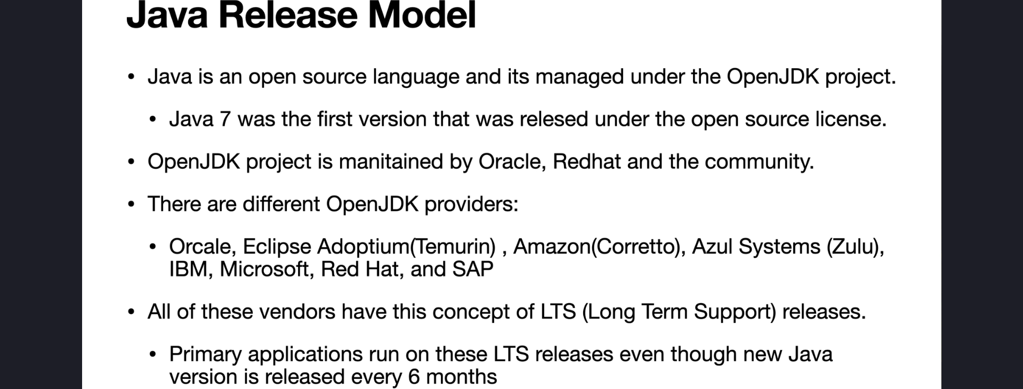

## Long-Term Support (LTS) Releases

Different OpenJDK vendors provide LTS versions, which have extended support. Enterprises generally move to new Java versions only when an LTS release is available.

Current LTS versions include:

- **Java 17**

- **Java 21 (latest LTS at the time of recording)**

- **Java 25 (scheduled for September 2025)**

## Where to Find Java Release Information

The instructor demonstrates how to find information on Java releases:

1. Using **ChatGPT** to list Java versions from JDK 1 to JDK 21.

2. Using **Web Search** to fetch the latest updates.

3. Referring to **Wikipedia and other sources** for Java version history and LTS releases.

## Course Updates

The course will be updated as new LTS versions are released, ensuring learners always have access to the latest features.

## Conclusion

This lecture provided an overview of modern Java, its evolving feature set, and the release model. The next lecture will cover the installation of the latest LTS version of Java.